**ROOM FOR IMPROVEMENT-**

**SHORT-TERM-**

* Get the links to the projects and Github/Linkedin/DMOJ to work
* ~~Reduce size of the icons (30px) but keep the ssame distance away.~~
* ~~Delete resume.html, but keep a copy for myself.~~
* Come up with look for each blog
* Make icon transparent
* Decorate home page:
  + Updates on site on the side bar
  + Advertise blog and featured blog posts (incl new ones)
  + Advertise projects
* ~~Reconfigure blog home page (my way, many personal websites for job seeking DO have a blog, no one has “Academics”)~~
  + ~~HOME~~
  + ~~ABOUT (just that) -> ACADEMICS & COURSEWORK (include link to a blog post: “Tips for each” and description of all the classes I took and links to blog post based on what I thought, link to notes I made too )~~
  + ~~PROJECTS~~
  + ~~BLOG -> several sections~~
  + ~~CONTESTS -> contest sols, etc. Contest advice might contain handouts (e.g. FFT) to unknown stuff such as undergrad math in competitions~~
  + ~~Might experiment with STEM -> PROJECTS, CONTESTS instead~~
* Add all the projects I do have
* DataTracker
* Company Data Tracker
* TUTORial (in progress)
* ChemCalculator (in progress) <- automatically figures out g/mol of a compound, looking it up in the periodic table is too hard.
* Web scraping proof of concept- LightningCite, DMOJQChecker (figure out every problem as a person has done from highest to lowest point)
* GameClock (in progress)

That “Beat the Casino” game (in progress)- could turn it into a text based RPG like game (ICS3U1)

* CodeHS Sols (in progress)
* DMOJ Solutions (in progress)
* Might worth looking at em, rem instead of px- see what might work
* Add more to “contest solutions”  
  Brainstorm and come up with a color scheme
  + I would change the colour of the website overall depending on the category of blog post, or competition type. Could give each project a colour scheme and change the website layout for each one. (e.g. hardcode the heading’s color COLOR1, the subtitle COLOR2, etc.)
* Come up with a layout for tablets and a layout for phones and use it
  + Laptop/Tablet: 2 projects per row, home bar is fixed past a certain point (jQuery)
    - ~~Index.html: the 3 panels have 100/100 width, tablet has 100/120 width~~
    - Solutions.html: 3 contests / row for laptops, 2 contests / row for tablets, 1 contest / row for phones
  + Phones: 1 project per row, home bar is not fixed, home bar is top down, and all dropdowns are click. (using JS, the dilemma is how to click on about?) To switch to click dropdowns, might need to put “About” somewhere else??? Actually, there will be no dropdown on the phones, it’s just that the “HOME”, “ABOUT” will be blockier. EDIT: use weebly dropdown system- <https://cheungphysics.weebly.com/physics-12.html> which looks different on phones.
  + 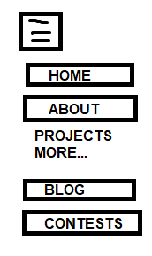
* ~~Give each homepage separate folders (e.g. poweredbypigeon.com/about.html -> poweredbypigeon.com/about/index.html). And then put down an absolute file path (C:/Users/simpleuser/Documents/TechnologyMain/Programs/Personal Website/) which will be changed to poweredbypigeon.com/ once I get it up. Looks cleaner that way. – is there a shortcut variable in HTML that gives you the file path to the website (can I change it to “C:/Users/simpleuser/Documents/TechnologyMain/Programs/Personal Website/” and “poweredbypigeon.com/”~~
* Quote randomizer
* Add content for:
  + Projects
  + Math Team Solutions
  + Contest Solutions
* Is there a way to have separate .html files, and on run time, insert the same piece of HTML code into all websites? (e.g. import(“footer.html”)). Because if I want to change something in the home bar, I have to do that for every single website and it wastes time.
* Alphabetize style.css
* Come up with <a> style guide, have on hover messages and colours (e.g. a bold red-orange line underneath)
* About page will have a list of technologies I use (HTML5, CSS3, JS) icons.
* Homepage (ONLY) has a logo at the beginning (with a geometric banner page) with my pigeon logo and name. Once you scroll down the position of homepage is fixed. Could make my logo green or cyber purple so I could stand out from background!
  + Right now I can’t make the home bar change position to fixed once it’s done scrolling past a certain location, but fortunately home page doesn’t have something like that.
* 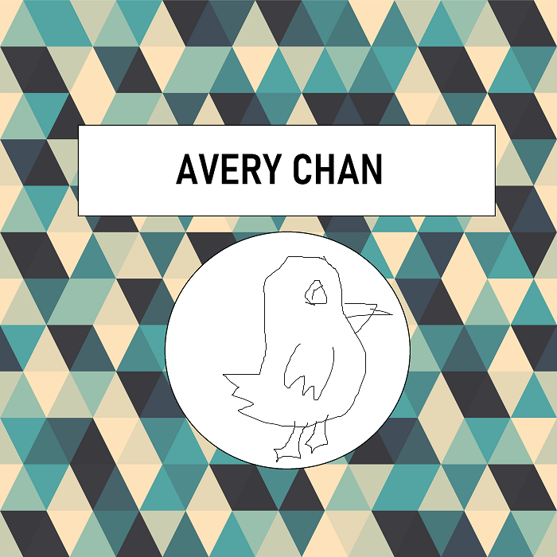
* About page should discuss technologies I’ve used

BLOG CONTENT:

* Canada Math Camp
* EMACS (later)
* The Metaverse
* Hydroponics
* (Previous essays, including Glendon John)
* AP Experience – and studying them (could talk about MIT OCW later)
* Book Reviews (textbooks I’ve read and stuff later) e.g. AoPS

Logos at the end:

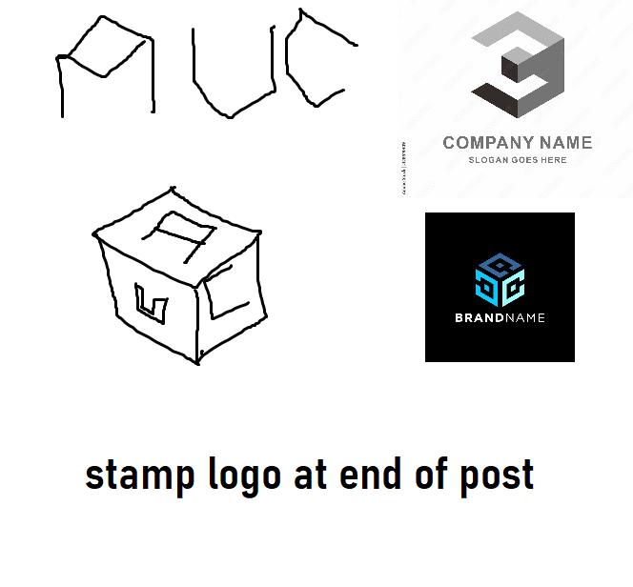

**LONG-TERM-**

* Make the 3 home page panels switchable (gallery)
* 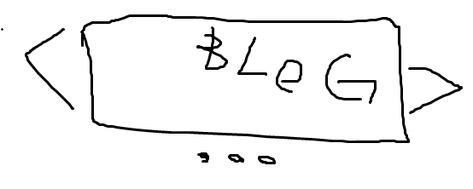
* Make 404 page with the home bar.
* Blog should support MathJax.js
* Roll out the blog content system (database, each blog should sport a certain ategory) . Blog posts should be given an ID (93020) so going to poweredbypigeon.com/blog/93020/ should give it
* Separate layouts for each content page
* Better individual project pages (with a side bar)
* JS: Click dropdowns for the homebar, and once you roll down past a certain point it becomes position: fixed (when it disappears), not immediately. This is to make dropdown mobile friendly.

**PLANS FOR LATER-**

My website contains:

* **LATER:** A blog
* (PERSONAL) Notes for everything, use similar framework <- like notes but with folders to organize them. (Like a wiki, can edit it)
* Social Media
* List of projects
* About Me
* Contest results (Math, computer, physics)
* **LATER: MATH TEAM RESOURCES <- link to a bunch of solutions**
* **Partner site:** A site with hints and solutions to various resources (handouts, math contests, chemistry contests, etc.) <- PDF’s
  + Categorize into “MATH”, “COMPUTERS”, “CHEM”, “PHYS”
  + AoPS Intro Count & Prob C5
  + AMC 10 etc.
  + AIME etc.
  + Avogadro 2021
  + OAPT 2021…
  + picoCTF 2021- link to blog. picoCTF writeups <- could do that! Put that on blog!

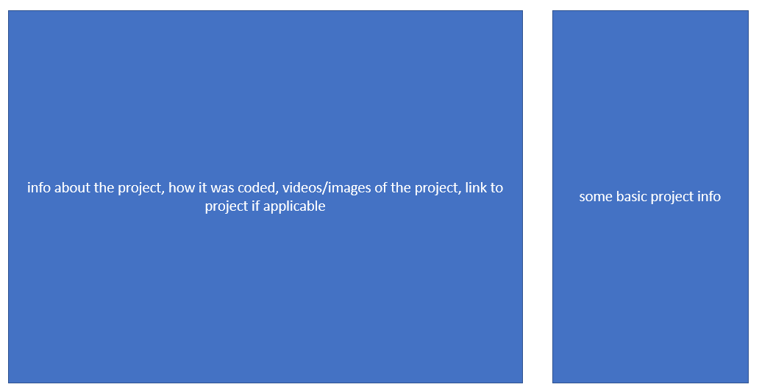

I'm thinking sidebar should be to the left. I would have it in the page for :

* individual project pages (maybe have it be rectangular and have a different bkgd color )
* when searching for blog posts, (like the Dell computer site, have the heading and a subtitle for each one, and a horizontal rule between each post). The sidebar would be like Dell CPU site: you get to filter certain stuff.
* as the table of contents for the blog posts, (like ryan10145 but to the left, or Discrete Open Math Books)

and I would give a slightly dfiferent look to each contest solutions page (and also link a certain contest to a blog post I had when doing the site). For example, I could have the PUMaC page fit the colour scheme (white with hints of black and red-ornage) . I would also give hints to the problems.

I would evolve this into Contest Checklist where each problem is categorized and you could have something like VQBC but better: select a list of problems from category “Intermediate Algebra”, and you could look at hints and eventually: the solution.

The ultimate ToC will be a notetaking system I Develop where you can:

* link your notes together similar to OneNote
* use images from GoodNotes if possible
* Like Wikia, be able to create your own notes without needing to edit the code
* Support for MathJax.js, and you could even make it look like a LaTeX document, complete with all the boxes! (but it would be easier to code)
* Collapse certain things (e.g. “examples”, “concepts”, “problems”)

It should look like <http://discrete.openmathbooks.org/dmoi3/sec_addtops-genfun.html> but more LaTeX like.

I could sell this (could call this “NoteCreator+” or something)

I would present an alpha version (offer it for free, and show it to universities) and do this later. It would help me in university.



Might add AoPS logo below the hr.

Inspirations:

* Halim’s site
* CSRMath: great blog

E

(code website this week, secretly)

Blogs should: (do this later)

* Support MathJax
* Have a date, list of categories (“Biology”)
* There should be a search bar (can I use a Google API?), and filter by category for posts
* Later on, find a way to use code so I can write blog posts without having to edit code. **** for bold.
* Have images push them to the left or right, have video and link support []().
* SOLUTIONS TO CONTESTS
* (Thoughts on the Metaverse)

Projets:

Have a page for each and provide a link. e.g. projects/01/

* DataTracker
* Company Data Tracker
* TUTORial (in progress)
* ChemCalculator (in progress)
* GameClock (in progress)

That “Beat the Casino” game (in progress)- could turn it into a text based RPG like game (ICS3U1)

* CodeHS Sols (in progress)
* DMOJ Solutions (in progress)

Social Media:

Links to GitHub/DMOJ/YouTube/Linkedin. <-| Use math contest training to make video solutions

Resume:

A PDF

Make sitemap and robots.txt

Need to come up with style guide

(Could upload notes and resources for all the courses I’ve been taking… MCR3U1, etc.)

**TODO:** Hackathons

**Later:** load Font Awesome for icons (Bootstrap? React?) Might want to recode it.

* Fix the home bar (HOME, ABOUT, BLOG…)

Have a single style.css.

In refs/ have an absolute file path that no matter in what folder it links back to the start. This is because relative file paths break if in different foldrs. Embed this into every site at the top.

And have variables (--) for colour palette.

Use averymchan.com/blog instead of averymchan.com/blog.html – looks more professional. Learn React for that (what about Tailwind and react icons?) Use Font Awesome for now

**MAIN CONTENT ISSUES:**

Come up with like 6 domain names for the website (make sure domain’s available), put down apps – poweredbypigeon.com. Need to finish “Projects” how to divide everything up into blocks.

Set up everything on GreenGeeks.

How do I add some margin space around main content?

~~Homepage put image of road map. (DID!)~~

**SITE REVIEWS:**

(inspiration)

Howard Halim's site-

+ Good use of spacing and centering to make the icons look neat (30 px)

+ Enough whitespace so it doesn't look cluttered

+ Too much rounding on the buttons, but I like how they change on hover

+ Good use of a gradient at the top

+ Great use of a colour scheme (sticking to 1 colour, I might do 2)

Headings match the colour too.

+ Good font

+ Some content (table expressing goals, handouts)

- No layout for phones

Pranav Konda's site-

+ Good use of icons

+ Good amount of content (book recommendations)

+ Nice resume

- Boring font

- Weird colour scheme & layout

RHHS CS site-

+ Good font (even if it's like DMOJ)

+ Cool dark colour scheme, passable navbar

+ Once again good icon spacing in the footer (like Halim)

- Lack of content

Ninjaclasher's site-

+ Good font (even if it's like DMOJ)- shines through in blog system

+ Great blog system- good use of icons

+ Icons on footer are good- centering them like everyone else.

+ Nice resume

+ Lots of projects- I liked how there's an image previewing each one and the overall box layout of each

+ Heading shows you what tab you're on

- Boring color scheme and heading, but it doesn't need to be that complex

- Each project should have its own page

TODO: add AoPS to mine.

<https://taylorsimpson.ca/>

Learn about em’s and px’s: <https://dev.to/theodorusclarence/back-to-basic-should-we-use-rem-em-or-pixel-1hd0>

TECH TO LEARN:

* More stuff about CSS
* React.js
* Bootstrap
* Tailwind CSS
* Ajax
* PHP
* MySQL
* Vue.js, possibly

Currently site is on GitHub Pages but if necessary I might need to move it to my own website (too many blog posts, db doesn’t work)

SUGGESTIONS: move to blog categories, each and general blog , could have book reviews (e.g. AoPS resources, like Pranav Konda's Recommendation site) compounded with notes for textbooks such as HRK (and study guides and problem solutions+hints), app reviews, etc. Could put up English essays too. Less writing on the front page, talk about blog posts. Minimal scrolling at the front (latest posts and the advertisements in like a gallery).

e